Hi,

It’s the third time I submit my work. I still have this error when I give : wget <http://139.162.160.241.xip.io> .

When i give this command : sudo tail /var/log/apache2/error.log, it shows me that it cannot import a pyhton module.

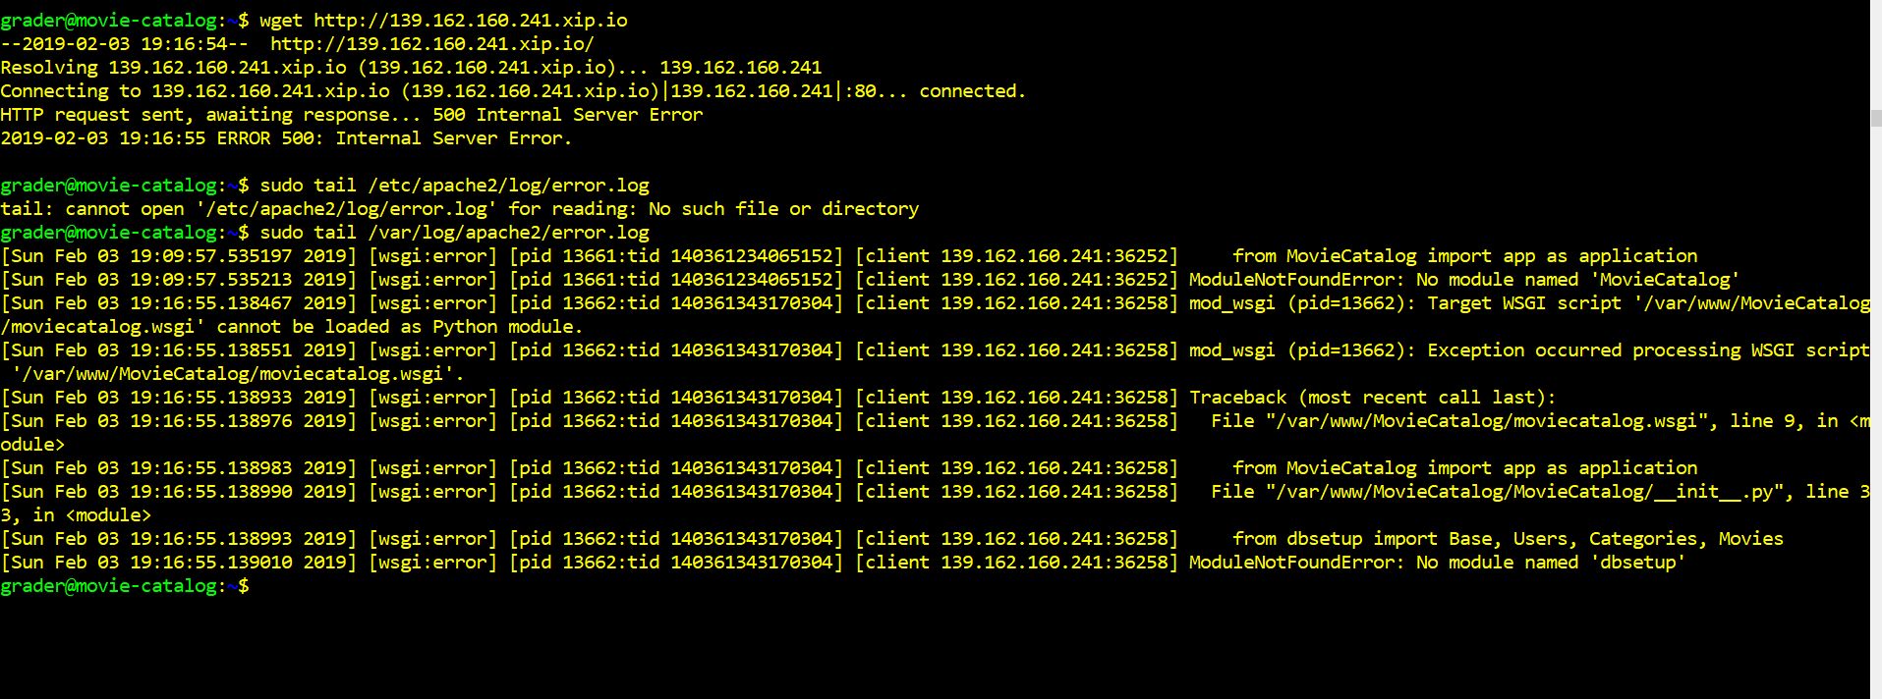

I have read a lot on internet and found many solutions that doesn’t apply to my case. Also, I posted a question about this on the udacity forum, but got no answer. Meanwhile, I used the default conf file for a proxy following this link : <https://www.digitalocean.com/community/tutorials/how-to-use-apache-as-a-reverse-proxy-with-mod_proxy-on-ubuntu-16-04#step-1-%E2%80%94-enabling-necessary-apache-modules>, that throws a bunch of proxy errors.

I also changed permissions , group and owners and I still have this error.

I followed carefully the reviewer comments and made all the changes, but I still have this error.

I remarked that if I want my site served on port 80, I have to stop apache2. That’s a bit weird…

So, I am not asking you to give me the solution, but please, tell me what I didn’t understand. I put a WSGIDeamon process with user=grader as advised, but still this error.

I am so close to the goal and honestly kind of desperating. I just want to understand where I am wrong.

Thanks in advance.